연구 내용 요약 및 계획

|  |  |
| --- | --- |
| 날짜 | 2020년 2월 14일 |
| **1. 이 번주 연구 관련 학습 내용 정리**   * **Udemy의 강의 듣기(** * **Jupyter note를 이용한 tensorflow실습** | |
| **2. 다음 주 학습 계획**   * **듣던 강의 끝까지 수강.**   <https://www.udemy.com/course/ml-bootcamp/> | |
| **3. 이번주 학습 내용 정리**  **Scikit-run.**  **Binary classification 데이터를 두 값으로 분리하는 방법이다. 이를 위해 regression을 사용한다.**  **이 알고리즘을 이용하여 kaggle의 타이타닉 dataset을 이용하여 사망자와 나이, 성별, 배우자 등에 대한 정보를 통한 사망률을 예측할 수 있다.** | |

Machin learning finds a function that matches best input to output best fit data.

Linear regression is supervised learning regression.

Simple regression is one dimension function.

Multivariable regression use x, y and z.

Cost function is find weight w minimize the cost or error.

Gradient descent is an optimization algorithm to minimize the cost function by iteratively moving in the direction of the steepest descent as defined by the negative of the gradient. Called learning rate

Abbreviation : 약어

Psychic learn for science kit for tool kit learn for ML. it is very powerful open source library and tool kit/provide pre processing of input data.

Linear use more than 100K data if not work, use text data->naive bayes

It is estimated model.

Decision tree simple decision rules. Simple to understand and to interpret and requires little data preparation. It is fast and uses a white box model

But it is risk of overfitting and can be unstable. Complex problems could not be learned risk of biased trees.

SVM is support vector machine . effective in high dimensional spaces and memory efficient versatile

KNN is nearest neighbors of a new data point are used for prediction. Use normalization

Enable method is to combine several estimates. Use predicted average

Pros of adaboost, cons of adaboost is weak learning model.

Grid search cross

Metrics

Evaluate model and R2 score(accuracy score) accuracy score use in metrics not regression models

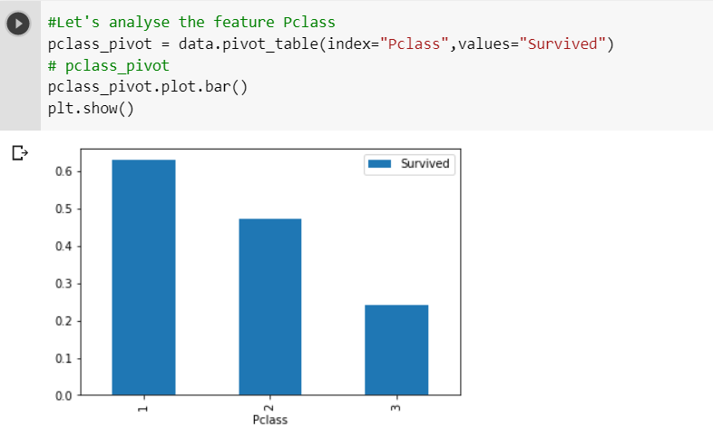

* Result as seat grade

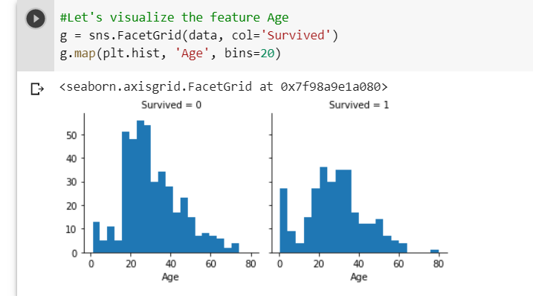

* result as age left = died, right= alive\

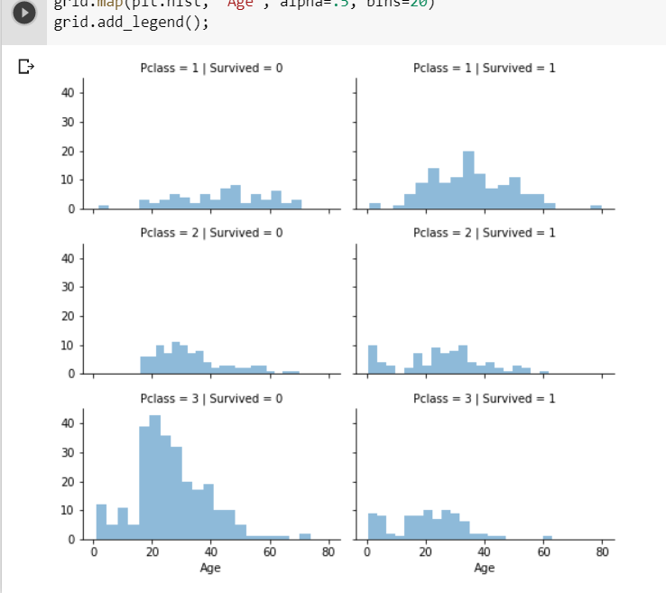

* combine above two result (age, pclass to survive)